Vrinda Store Data Analysis

Objective :-

Vrinda Store want to create an annual sales report for 2022. So that, Vrinda can understand their customers and grow more sales in 2023.

**Process :-**

**Step 1 :- Data Cleaning**

Removing duplicates, null values ,etc. Keeping data in one format in column.

**Step 2 :- Data Processing**

Applying formulas to get data which helps to get required output.

**Step 3 :- Data Analysis**

Analysing data, Making pivot tables, charts, etc.

**Step 4 :- Interactive Dashboard**

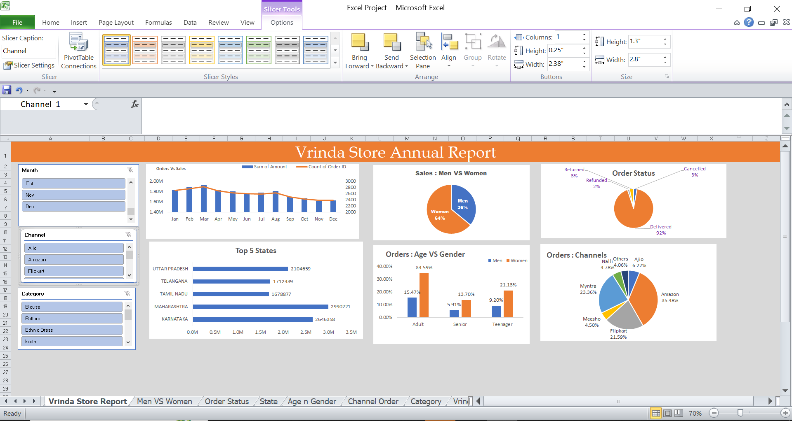

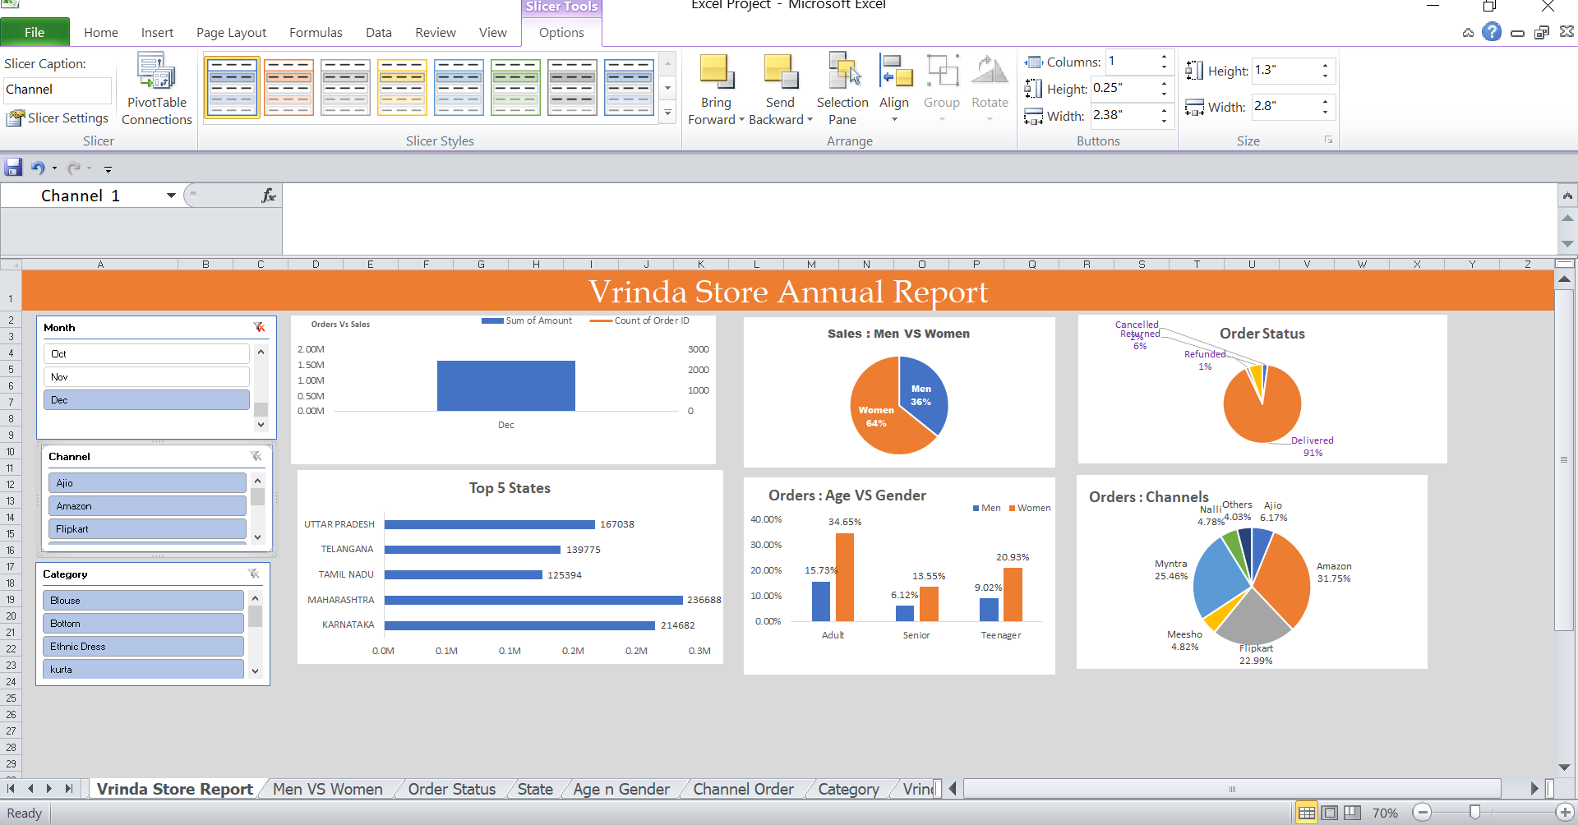

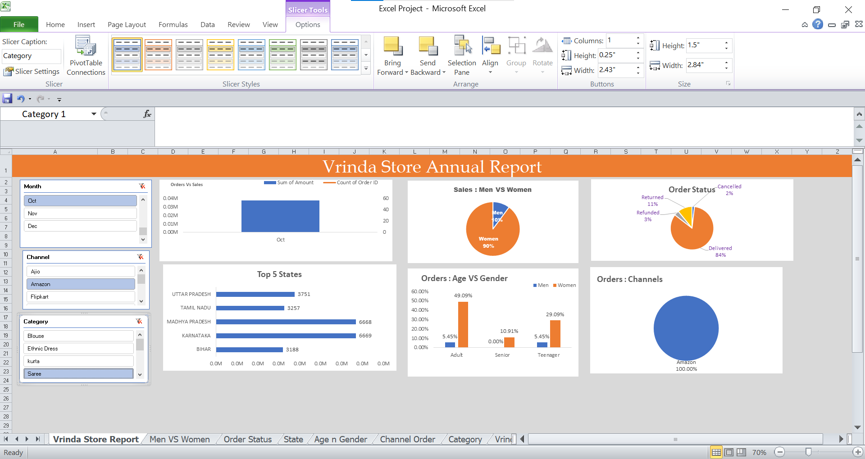

**Step 5 :-**

Sample Questions :-

* Compare the sales and Orders using single chart.

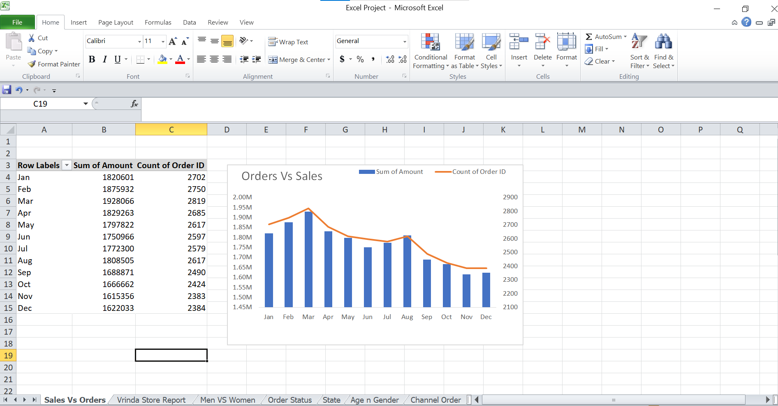

* Which month got the highest sales and orders? – **March 2022**
* Who purchased more – Men or women in 2022? – **Women**

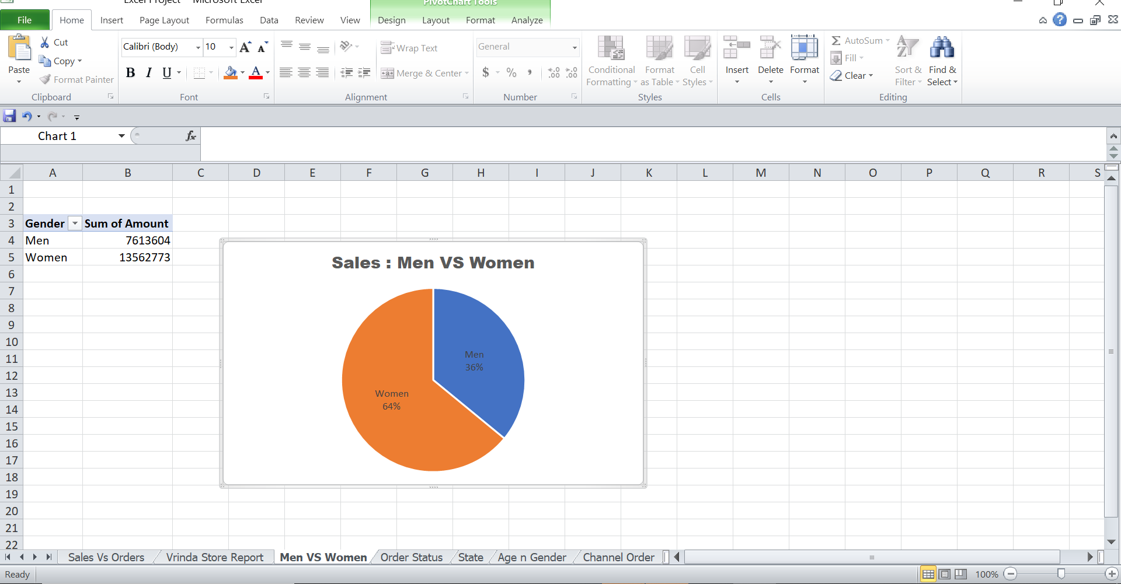

* What are different orders status in 2022? – **Cancelled, Delivered, Refunded , Returned**

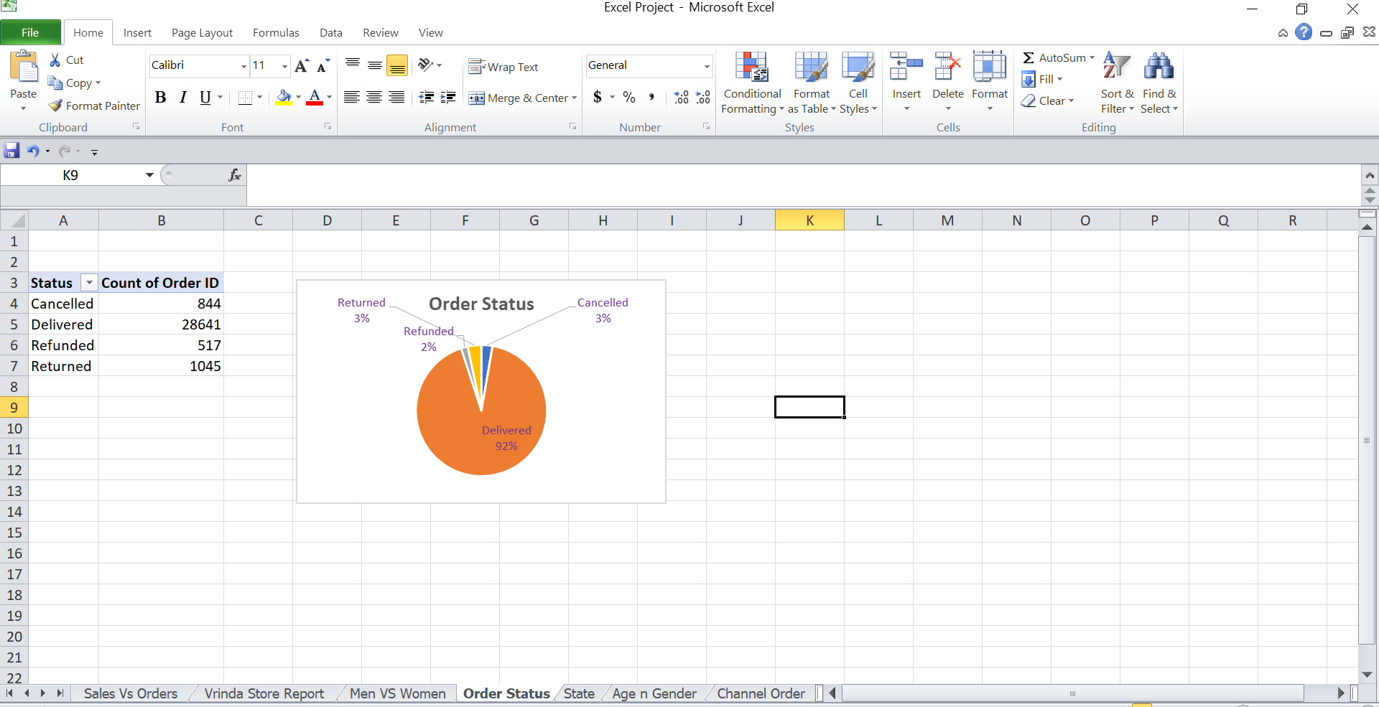

* List top 5 states contributing to the sales?

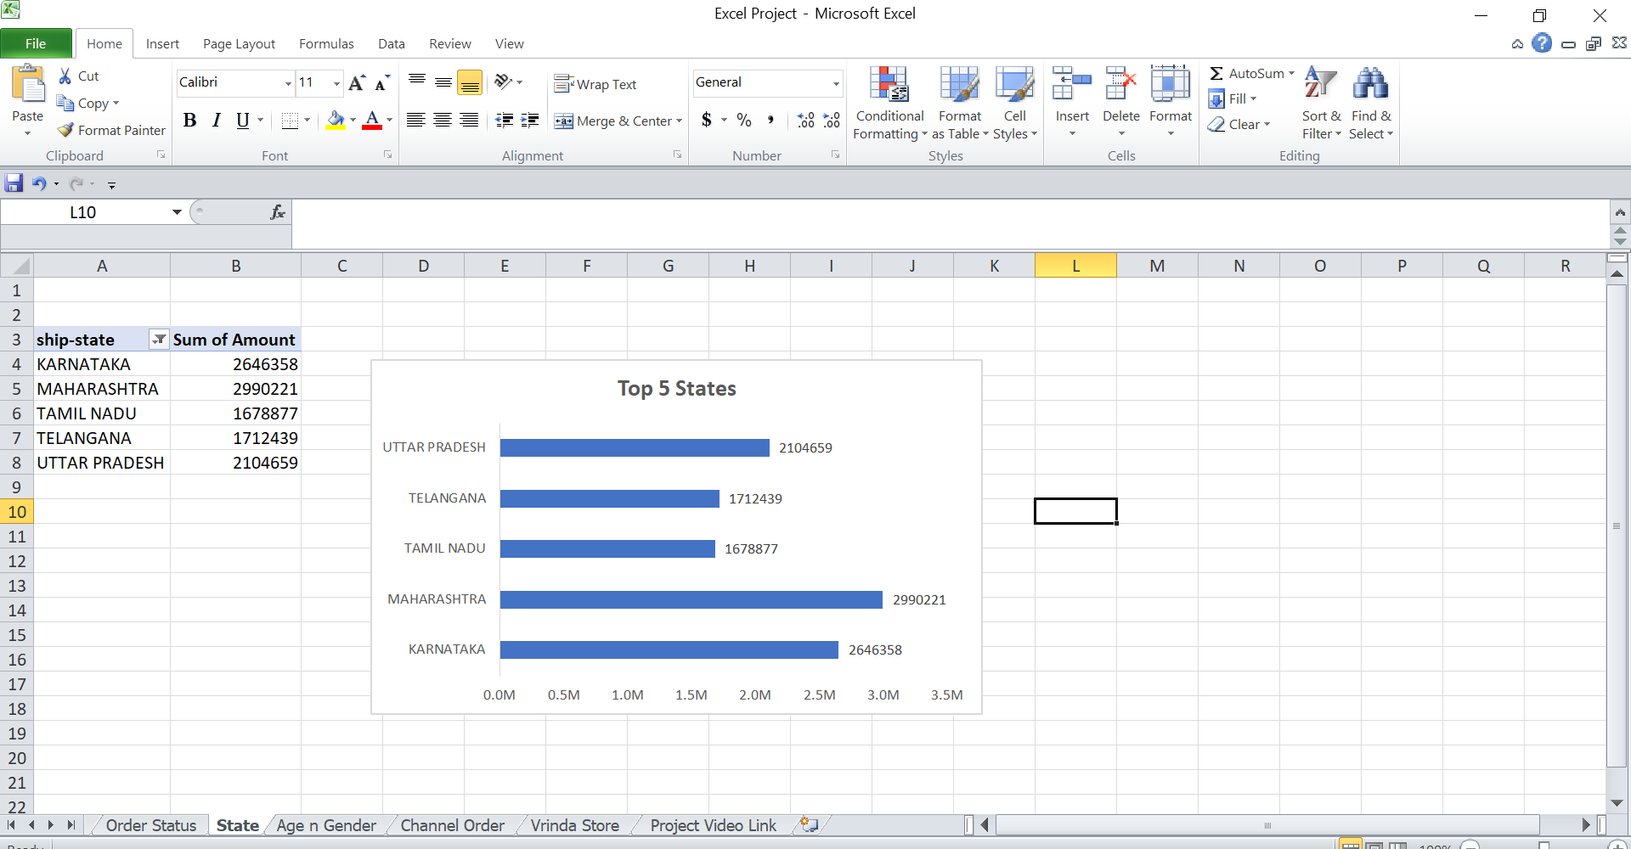

* Relation between Age and Gender based on number of orders.

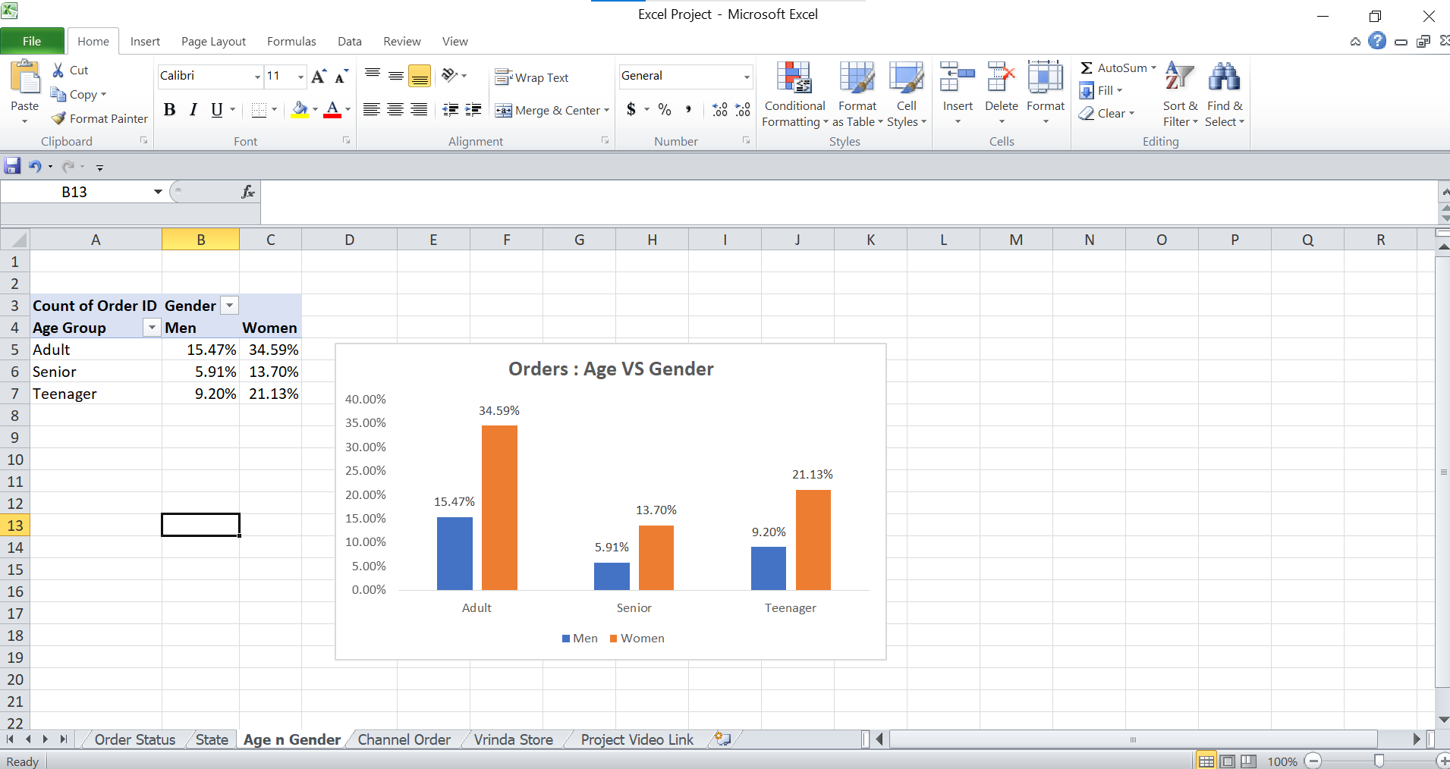

* Which channel is contributing to maximum sales? – **Amazon**

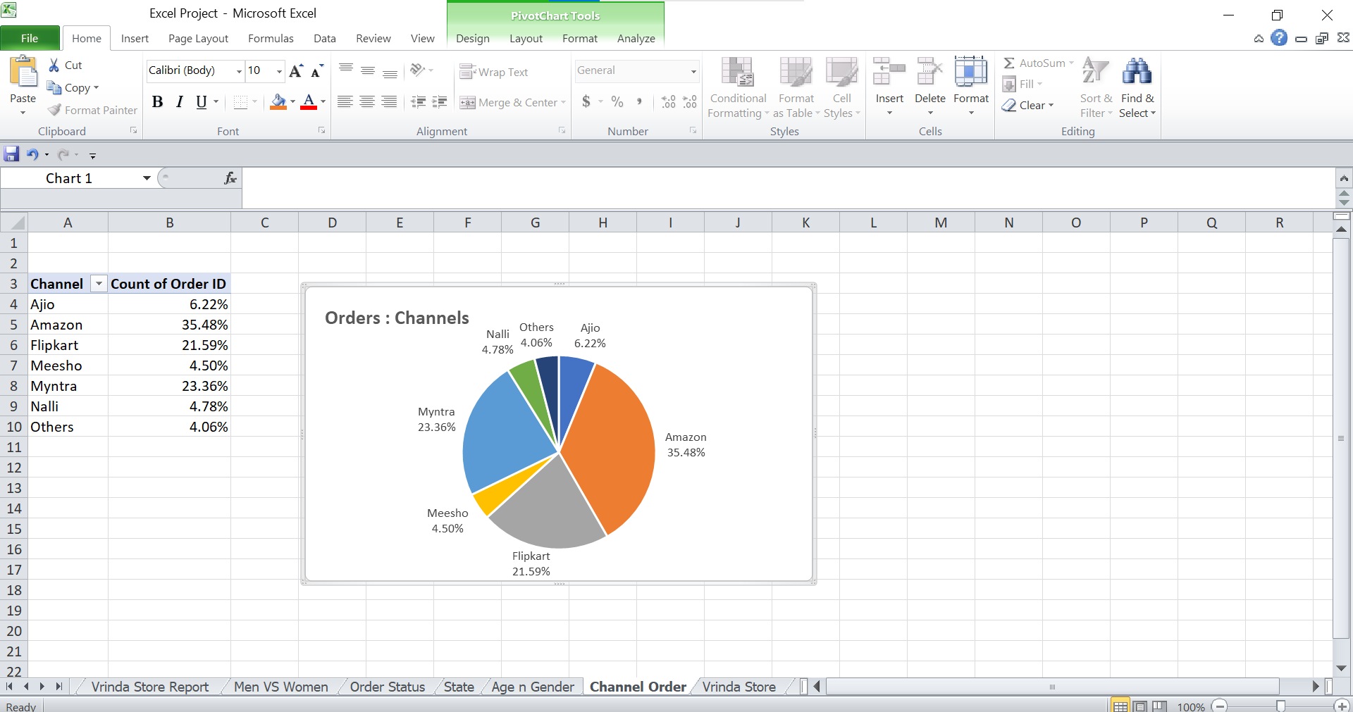

* Highest Selling Category? - **Set**

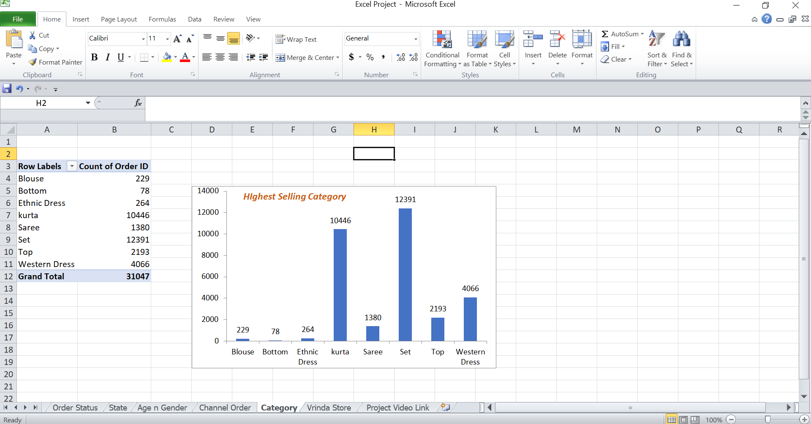

Insights :-

* Women are more likely to buy compared to Men (65%)
* Maharshta, Karnataka and Uttarpradesh are top 3 states (35%)
* Adult age group (30-50yrs) contributing more (50%)
* Amazon, Flipkart and Myntra channels are max contributing.(80%)

Conclusion :-

Target women customers of age group (30-50yrs) living in Maharashtra , Karnataka and Uttarpradesh by ads/offers/coupons available on Amazon, Flipkart and Myntra.